**Session report 10/01/2023:**

*LABAUVIE – RAFFAELLI EVA*

*ROB3*

I finalized the modelling of the collecting wheel for the dishes.

I added a slope inside so the rubbish can fall on the future conveyor.

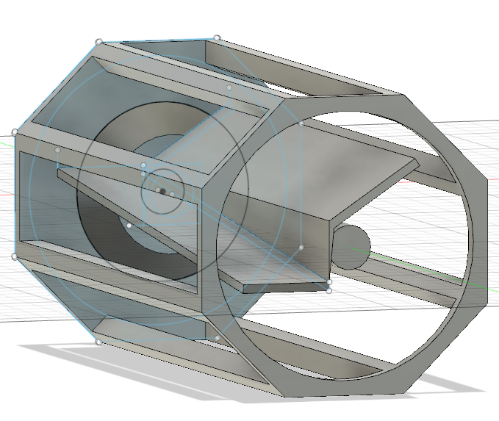

And added a wall inside to prevent the collected items to fall in the wrong place :

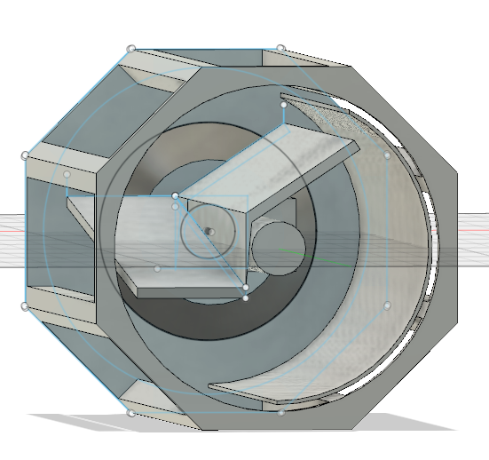

I also created a piece whose purpose is to hold the slope and the wall while being stabilized on the axis (without being connected to it so it doesn’t fall).

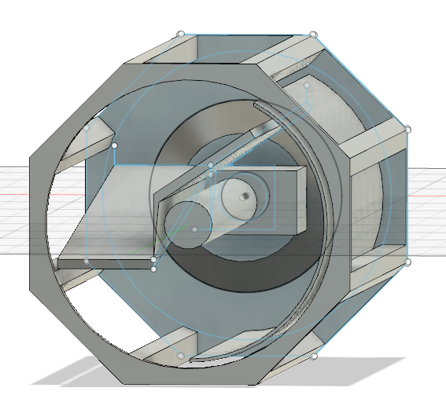

I made holes in the slopes so the sand can go through it and isn’t collected.

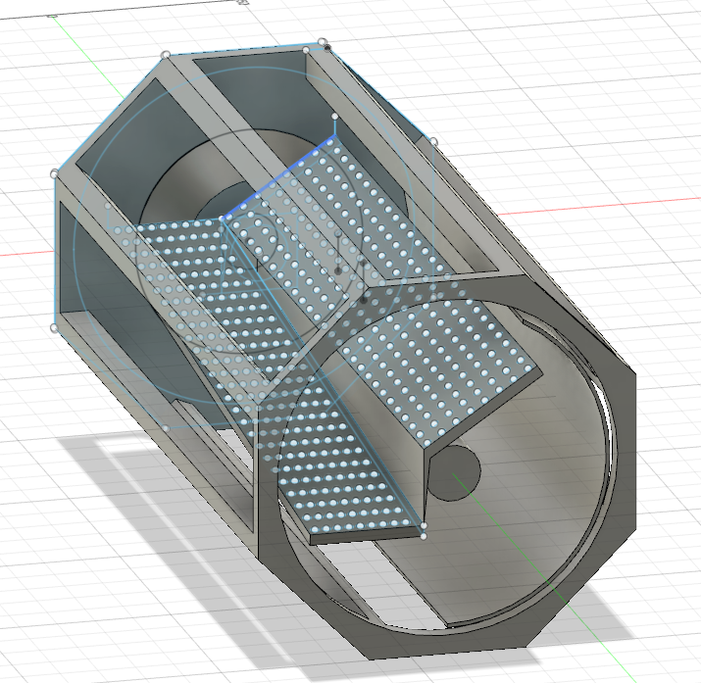

Now I need to try modelling the shovels to pick up the sans and the rubbish with the wheel.

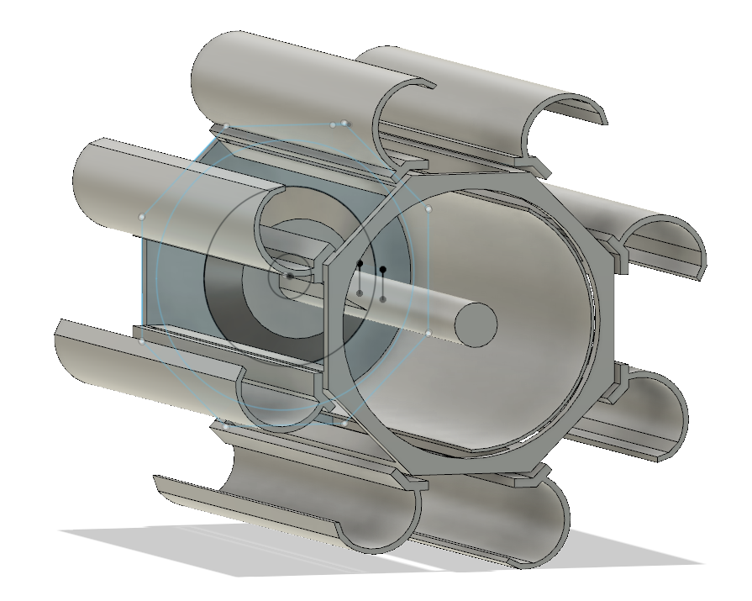

Here is a first try but I might make modification on the shovels shape.